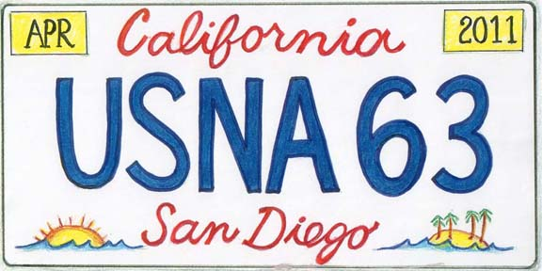
Manchester Grand Hyatt Hotel Reservations

We have contracted with the Manchester Grand Hyatt Hotel on behalf of the Class for our Mid Term Reunion at extremely attractive rates of $131 (plus taxes and fees) for a standard double and king room from March 28th to April 4th. The Hyatt also offers a variety of other types of rooms, but these are not covered by our contract rates.

For a virtual tour of this magnificent Hotel, visit: http://manchestergrand.hyatt.com/hyatt/hotels/index.jsp?null.
To register online, go to our special Class Registration web site at: https://resweb.passkey.com/Resweb.do?mode=welcome_ei_new&eventID=2718111.
To register by telephone, call 888-421-1442, and identify yourself as a member of the “U.S. Naval Academy Reunion Class of 1963”
Because we are financially very risk averse, our “guarantee” to the Hotel is for far less rooms than our expected number of attendees. Therefore, a word to the wise: make your hotel reservations as soon as possible to get these great rates!

A Sample of the many Attractions awaiting you in San Diego

San Diego Tourist and Convention Bureau: http://www.sandiego.org/nav/Visitors.

USS MIDWAY: www.midway.org.

Old Gas lamp Quarter: www.gaslamp.org.

Downtown area Restaurants: http://www.sandiegorestaurants.com.

Old Town Trolley Tours: http://www.trolleytours.com/san-diego/

San Diego Zoo and San Diego Wild Animal Park: http://www.sandiegozoo.org/.

Balboa Park: www.balboapark.org.

Seaport Village: www.seaportvillage.com.

Hotel del Coronado: http://www.hoteldel.com/.

Old Town San Diego: http://www.oldtownsandiegoguide.com/.

Sea World San Diego: http://www.seaworld.com/sandiego/.

Tours/Visits to these and many other venues may be arranged through the Hyatt Hotel Concierge Desk.

